Explanation of my work :

  - first we use matlab and we record the voice. then we design a low bass filters with different
  - cut-off frequency . then we chose the voice at cut-off frequency (20000 hz &4000 hz) to know what happened at this cut-off frequency .then we plot the input ant the output record in different domain (time and frequency ) .and this is the result of two signal (records).

Why we chose this sampling frequency and bit depth ?
- We chose sampling frequency (44100) just to improve the qulity of voice .we know we can use less than this number .

- We chose the bit depth (16-bit ) because that is the ideal number of bits use to store the voice .

First signal:

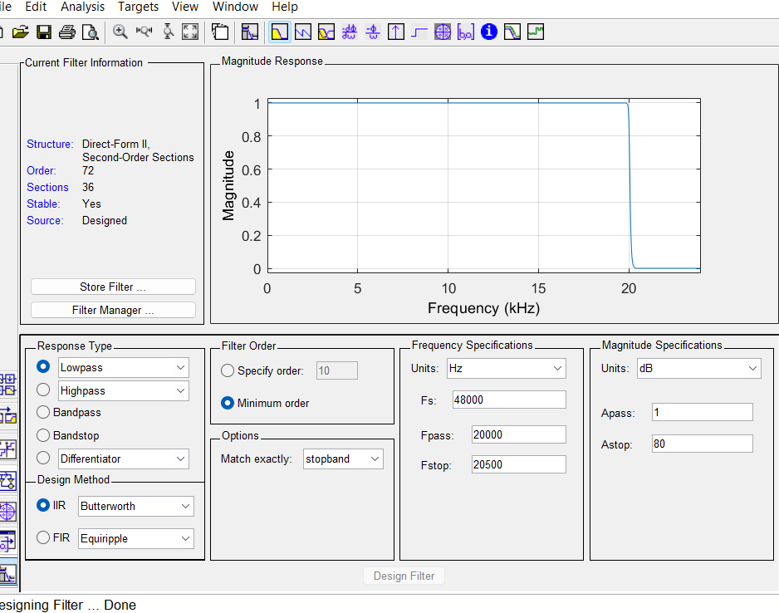
the result at (20000 Hz):

Figure 1.the frequency response of the filter
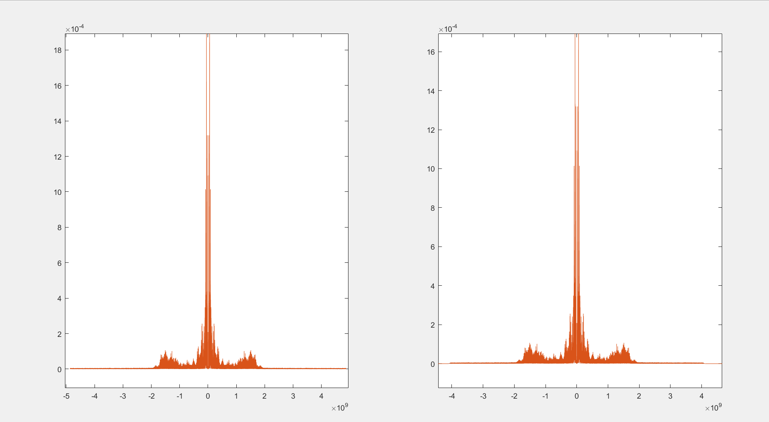
Figure 2.the magnitude spectrum of the first sgnal @20000 Hz.(input and output) in frequency response
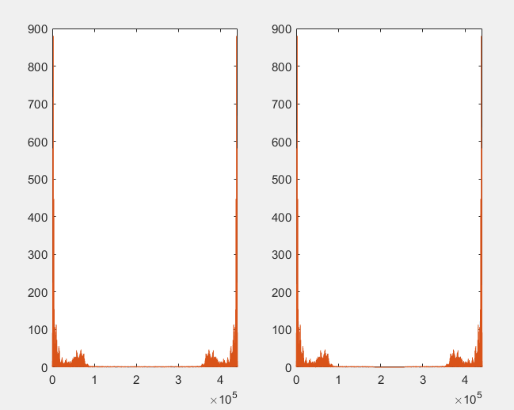
Figure 3. .the magnitude spectrum of the first sgnal @2000 Hz.(input and output) (k)

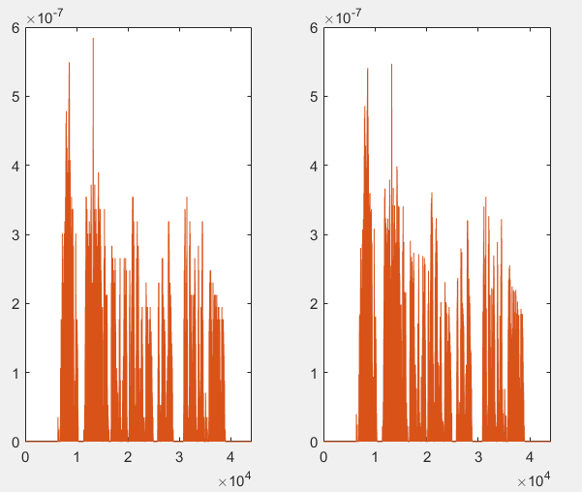

Figure 4 .the magnitude spectrum of the first sgnal @20000 Hz.(input and output) (Hz)

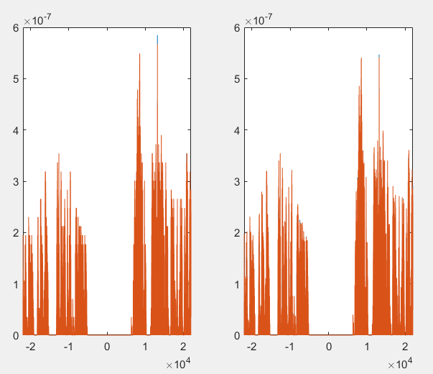
Figure 5.the magnitude spectrum of the first sgnal @20000 Hz.(input and output) (k) using fftshift’

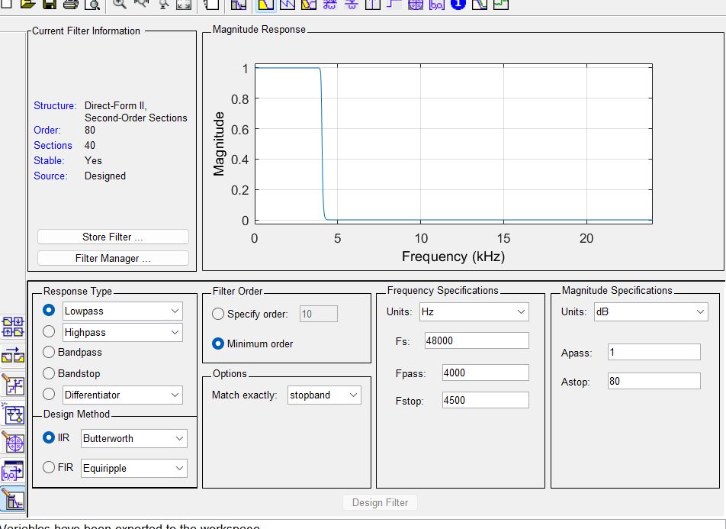
The results at (4000 Hz):
Figure 6.the frequency response of the filter(4000 hz)

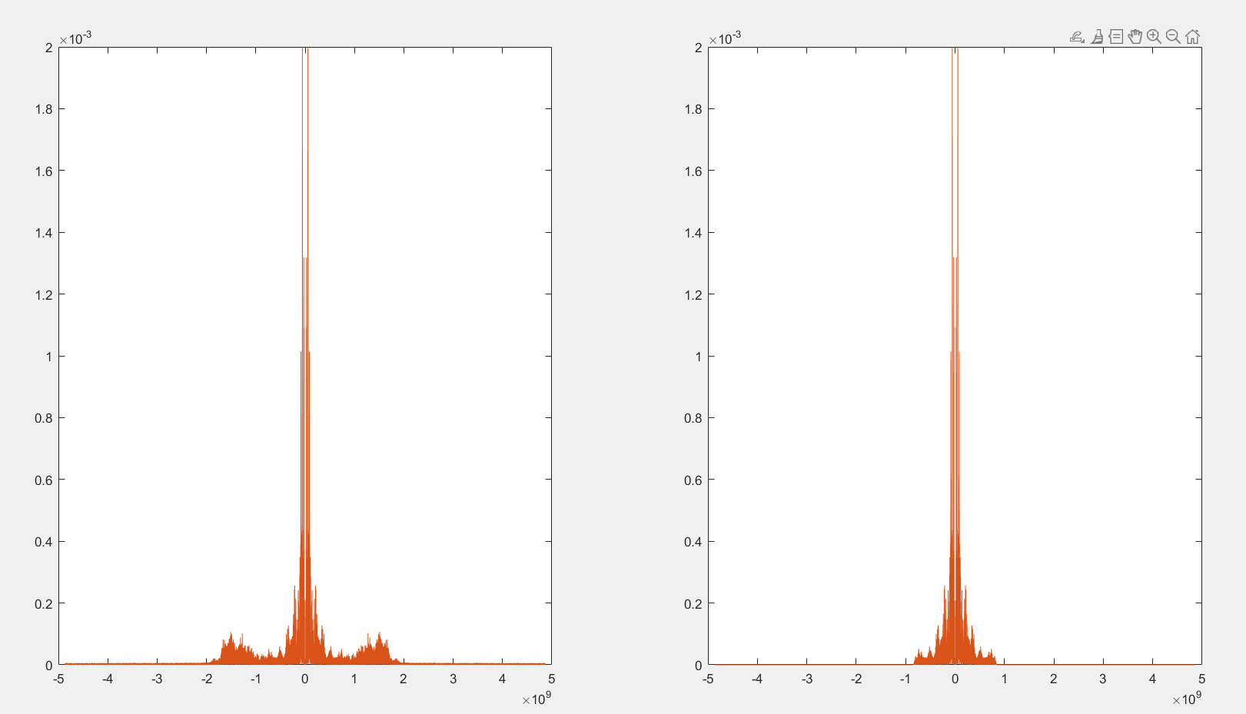
Figure 7..the magnitude spectrum of the first sgnal @4000 Hz.(input and output) in frequency response

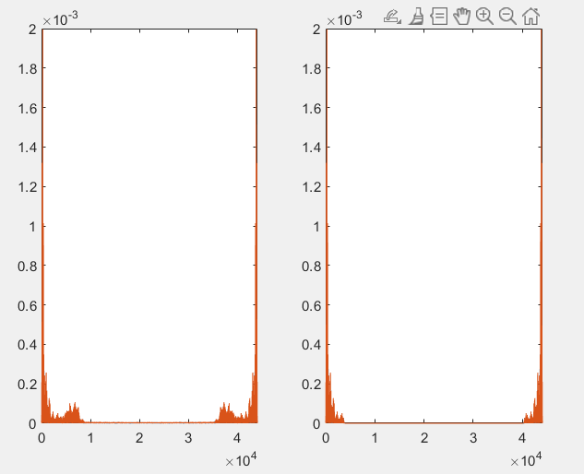
Figure 8.the magnitude spectrum of the first sgnal @4000 Hz.(input and output) (k)

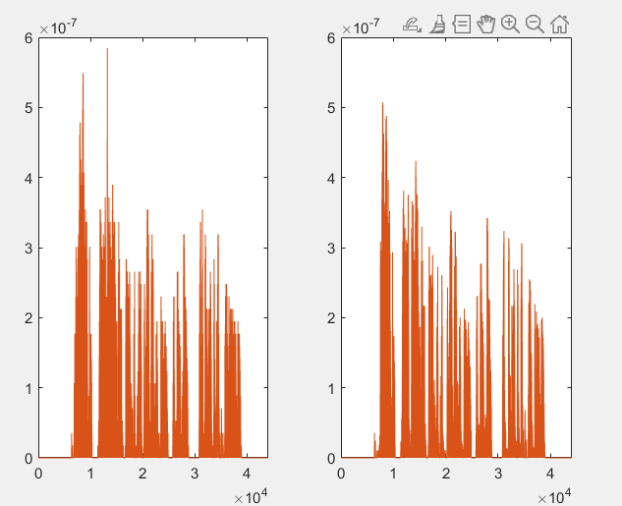
Figure 9.the magnitude spectrum of the first sgnal @4000 Hz.(input and output) (Hz)

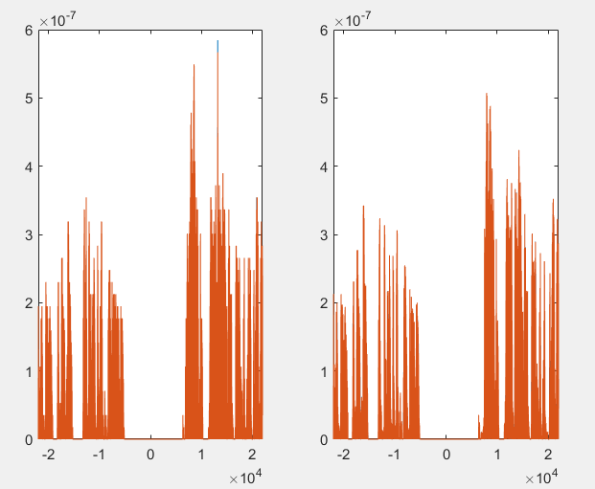
Figure 10.the magnitude spectrum of the first sgnal @4000 Hz.(input and output) (k) using fftshift’

The seconed signal:

the result at (20000 Hz):
Figure 11..the frequency response of the filter

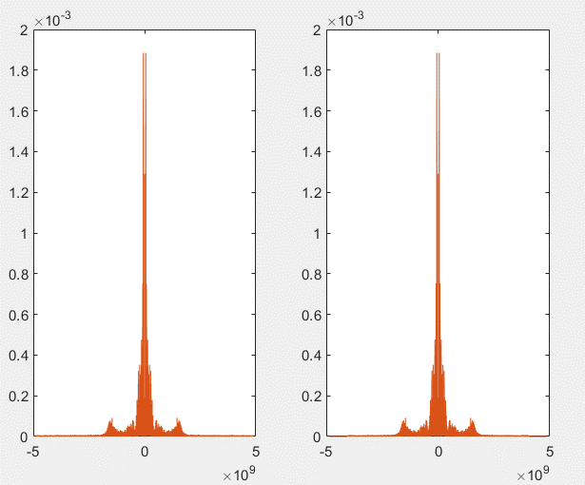
Figure 12.the magnitude spectrum of the second sgnal @20000 Hz.(input and output) in frequency response

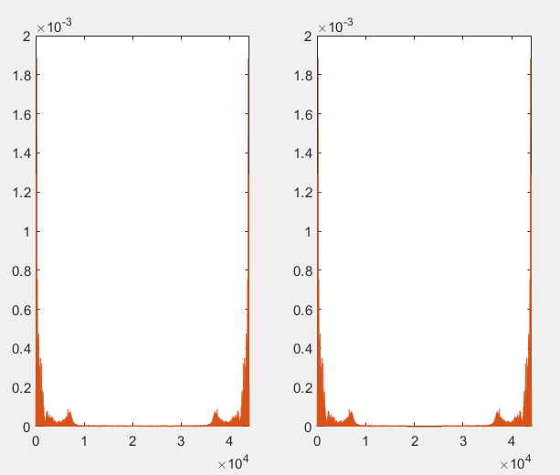
Figure 13..the magnitude spectrum of the second sgnal @20000 Hz.(input and output) (k)

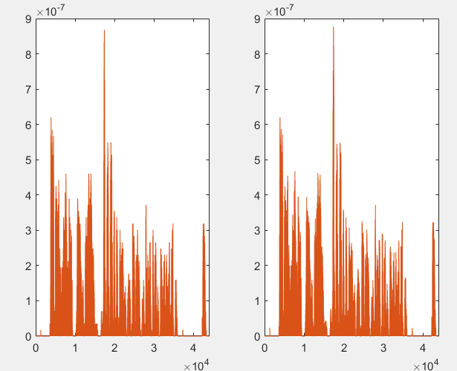
Figure 14..the magnitude spectrum of the second sgnal @20000 Hz.(input and output) (Hz)

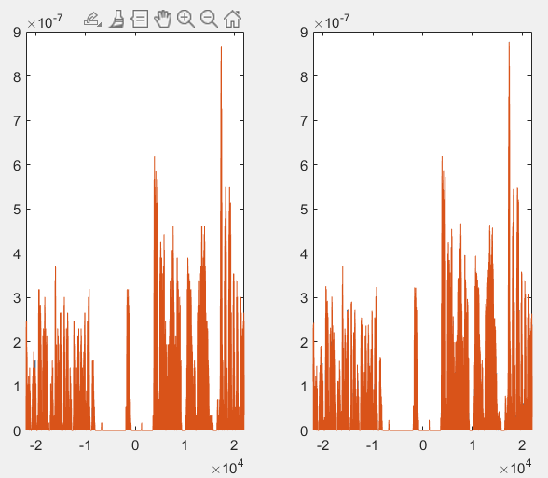
Figure 15.the magnitude spectrum of the second sgnal @20000 Hz.(input and output) using fftshift’

the results at (4000 Hz)
Figure 16..the frequency response of the filter(4000 hz)
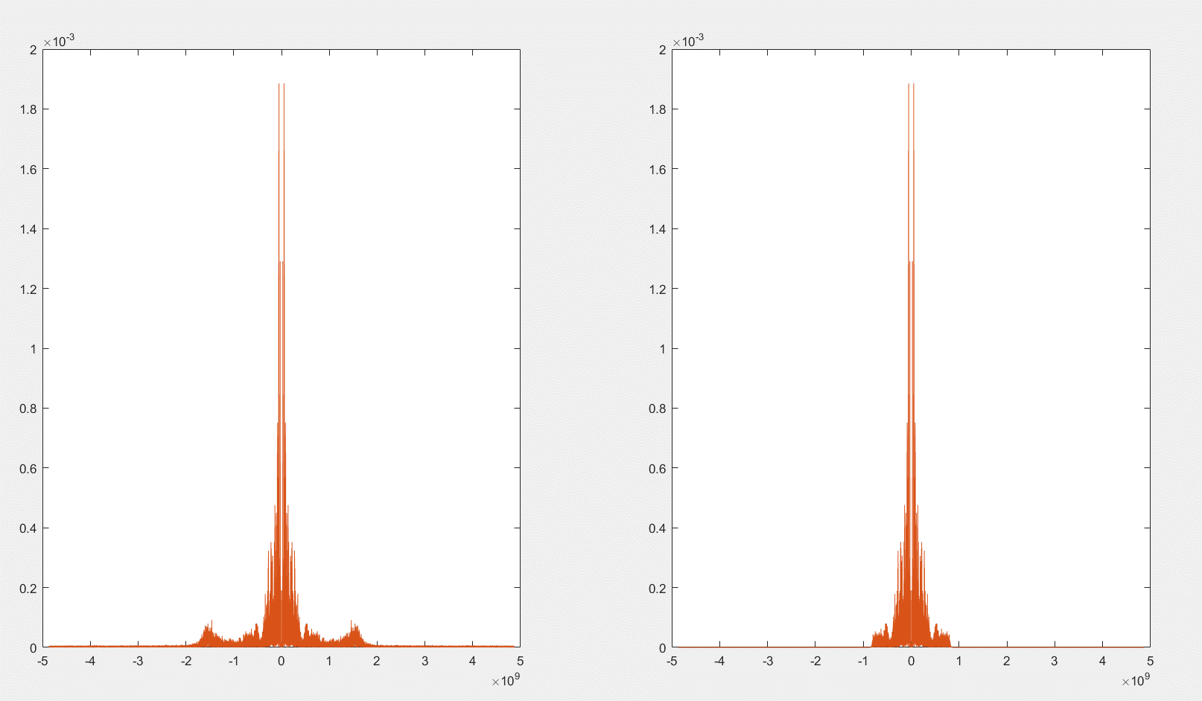
Figure 17.the magnitude spectrum of the second sgnal @4000 Hz.(input and output) in frequency response

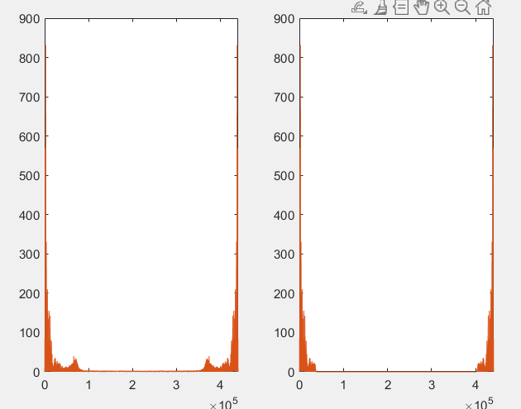
Figure 18..the magnitude spectrum of the second signal @4000 Hz.(input and output) (k)

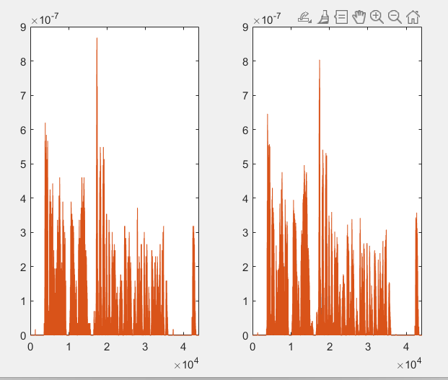
Figure 19..the magnitude spectrum of the second sgnal @4000 Hz.(input and output)

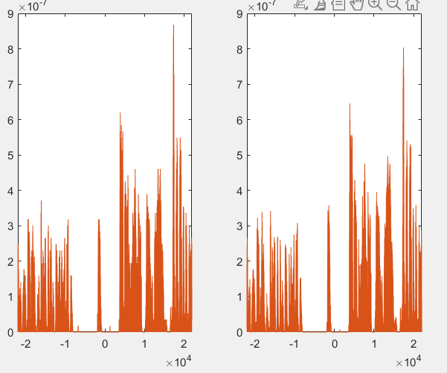
Figure 20..the magnitude spectrum of the first sgnal @4000 Hz.(input and output) (k) using fftshift’

For_modulation (D&E):

Explanation of my work :
First we need to get the carriear signal which is (cos) .the we must make sure that the last freq in the input signal (filtered signal with cut-off frequency 4000 Hz) dose not interaction with the carriear .
The me multiply the sugnals with different frequency and cosine and add rach signal to get the modulation of two signal .
Then we ma;e the code tell the user which signal do you want to here (like the radio).then after wi chose the signal we design a band bass with right (Fpass & Fstop) to do Demodulation to the selected signal .
The we multiply the modulation signal with carriear signal which have frequency we chose .
The last step is design a low bass filter with gain 2 to get the output signal .
And this is the results.

For signal (1):

For signal (1):
For signal (1):

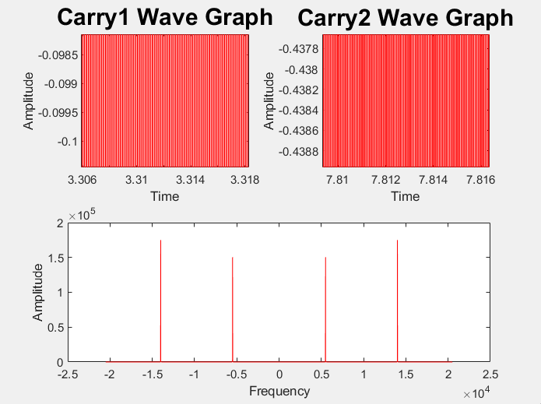

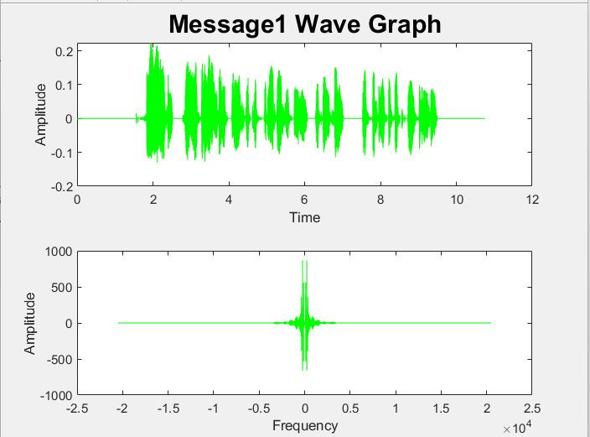
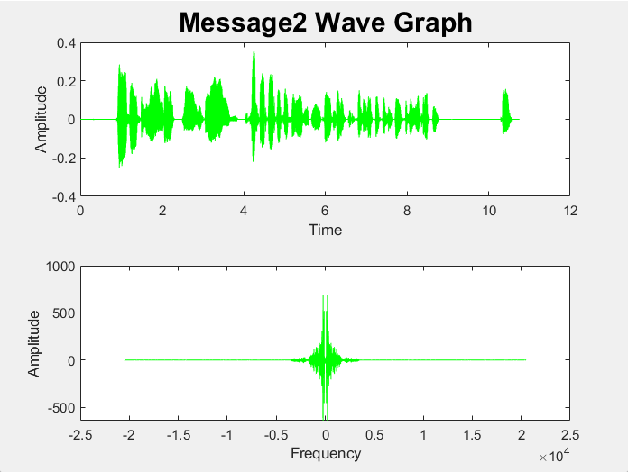

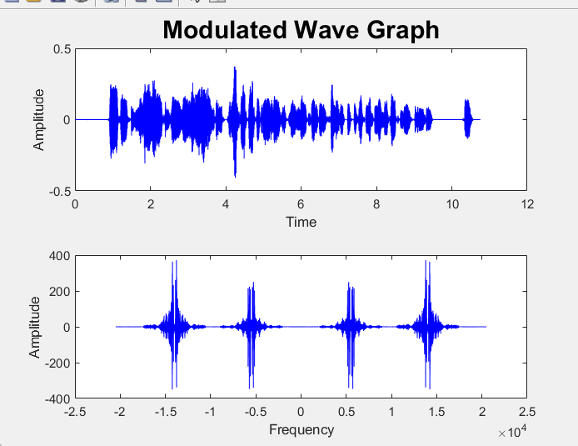
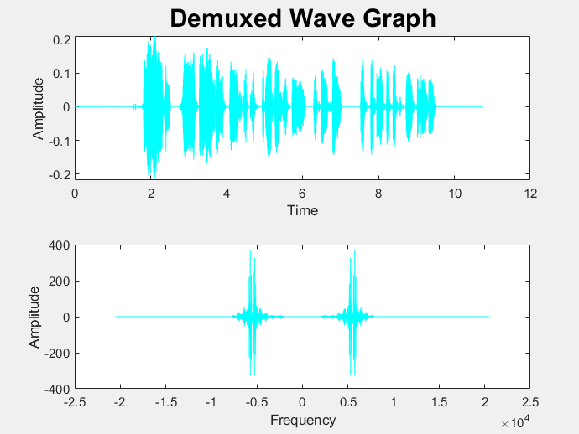

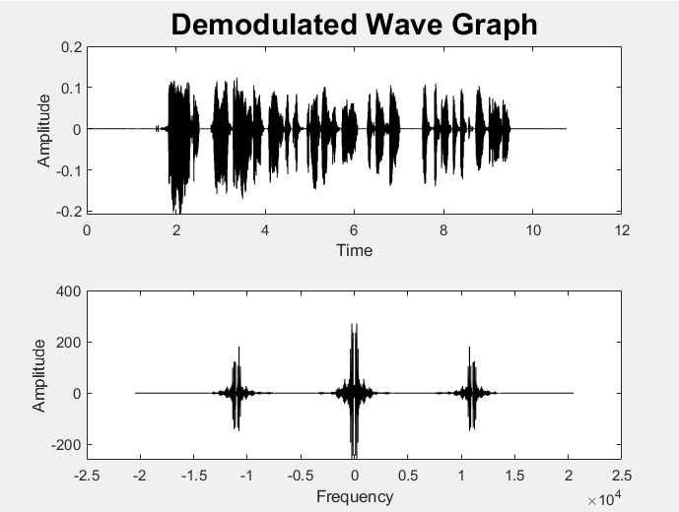
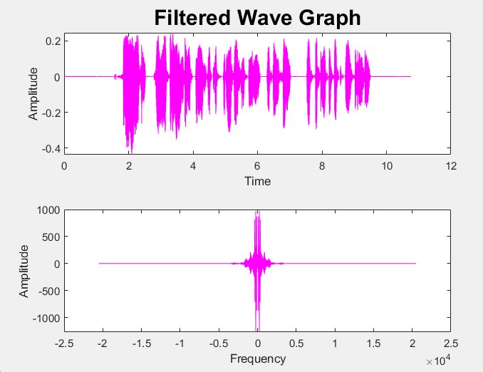

For signal (2):
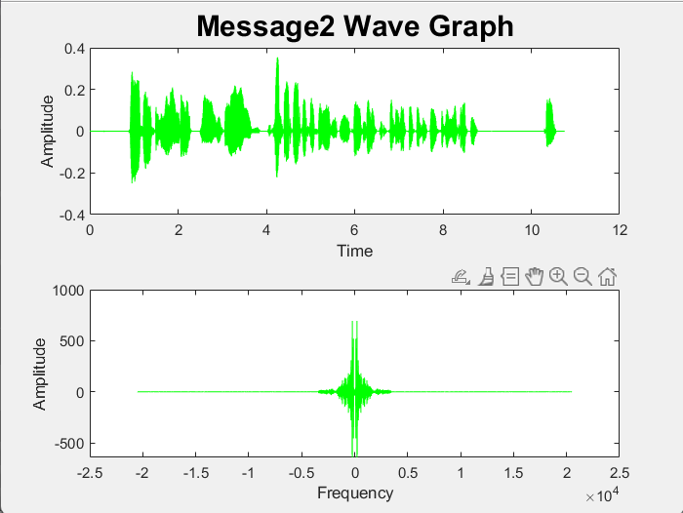
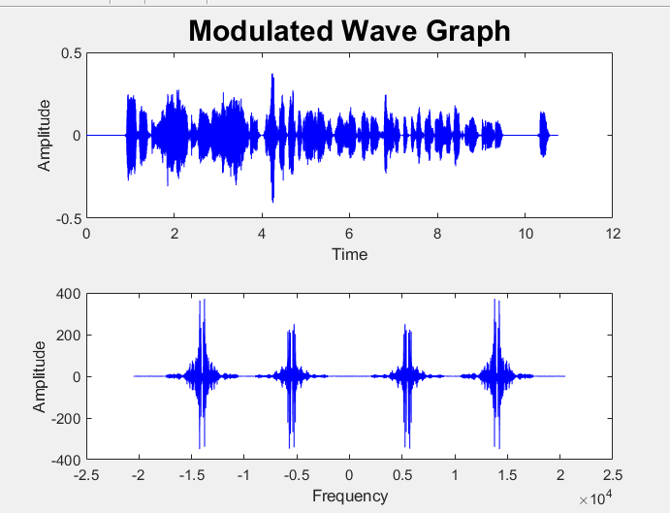

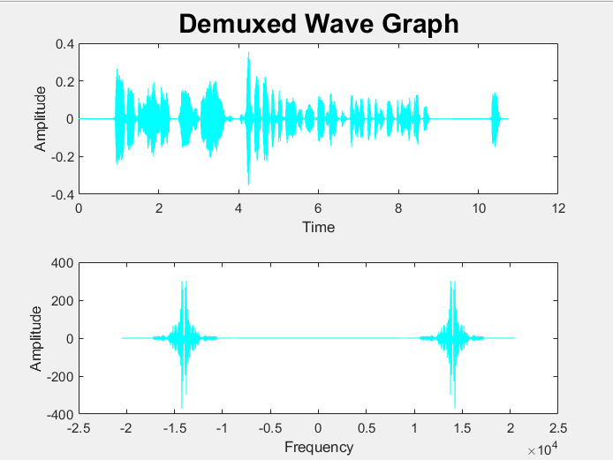
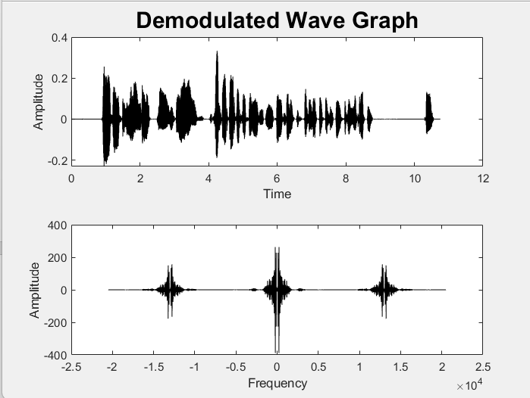
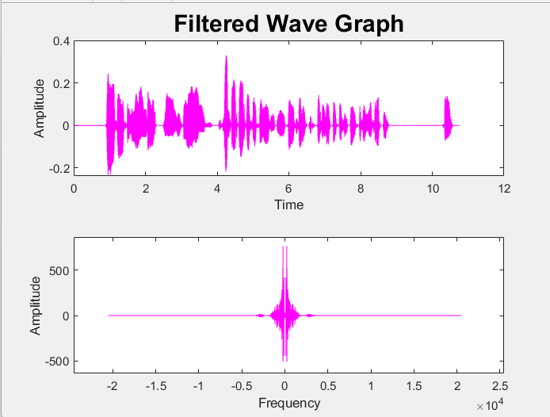

- D)Why we chose the carrier frequency(7500 Hz)&(16000 Hz)?
- because we the last frequency in the input signal is equal to (4500 HZ).we use the signal the we get from filter function in low frequency (Fstop=4500 Hz).so we use (7500 Hz) or (14500) as a carrier frequency to avoid any ineraction between the modulated signal and the filtered signal.

The equations :

𝑝 (𝑡) = cos (𝜔0𝑡) (1)

𝑟 (𝑡) = 𝑠(𝑡) 𝑝(𝑡) (2)
Where p(t) is the carrier signal,s(t) the signal and the r(t)is the modulated signal in time domain .

$R\left(ω\right)=\frac{1}{2π}$𝑆 (𝜔) ∗ 𝑃(𝜔) (3)
Where S(w), P(w)and R(w) in frequency domain .

$R1\left(ω\right)=\frac{1}{2}*S1\left(ω-ωo1\right)+\frac{1}{2}*S1\left(ω+ωo1\right)$ (4)
We will make this step with the second signal , an get R2(w)

$R2\left(ω\right)=\frac{1}{2}*S2\left(ω-ωo2\right)+\frac{1}{2}*S2\left(ω+ωo2\right)$ (5)

$Rtot\left(ω\right)=R1(w)+R2(w)$ (6)

Wher 𝜔o is the freq if carrier and 𝜔 is the freq of the signal.
now we mill make a band bass filter to chose which signal will be demodulated.

Then we do the demodulation
𝑝 (𝑡) = cos (𝜔0𝑡) (7)
𝑟𝑡=𝑠(𝑡)*𝑝(𝑡) (8)
Where p(t) is the carrier signal,s(t) the signal and the r(t)is the modulated signal in time domain .

$R\left(ω\right)=\frac{1}{2π}$𝑆 (𝜔) ∗ 𝑃(𝜔) (9)
Where S(w), P(w)and R(w) in frequency domain .

Then we will use filter with Gain (2) to get the output signal .

We must make sure 𝜔0>𝜔1 to avoid any interaction between the modulated signal and the filtered signal.

.the frequency response of the band bass filter for (7500 Hz)

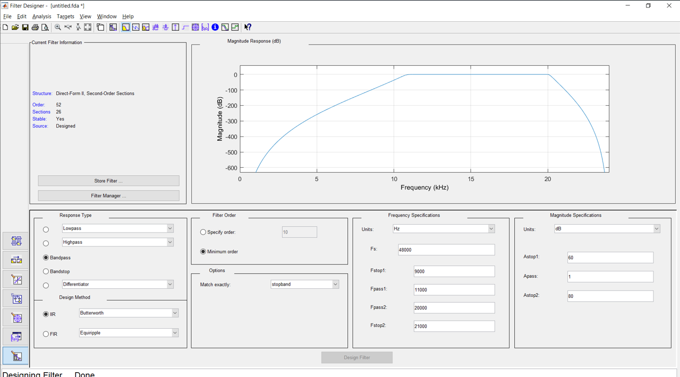
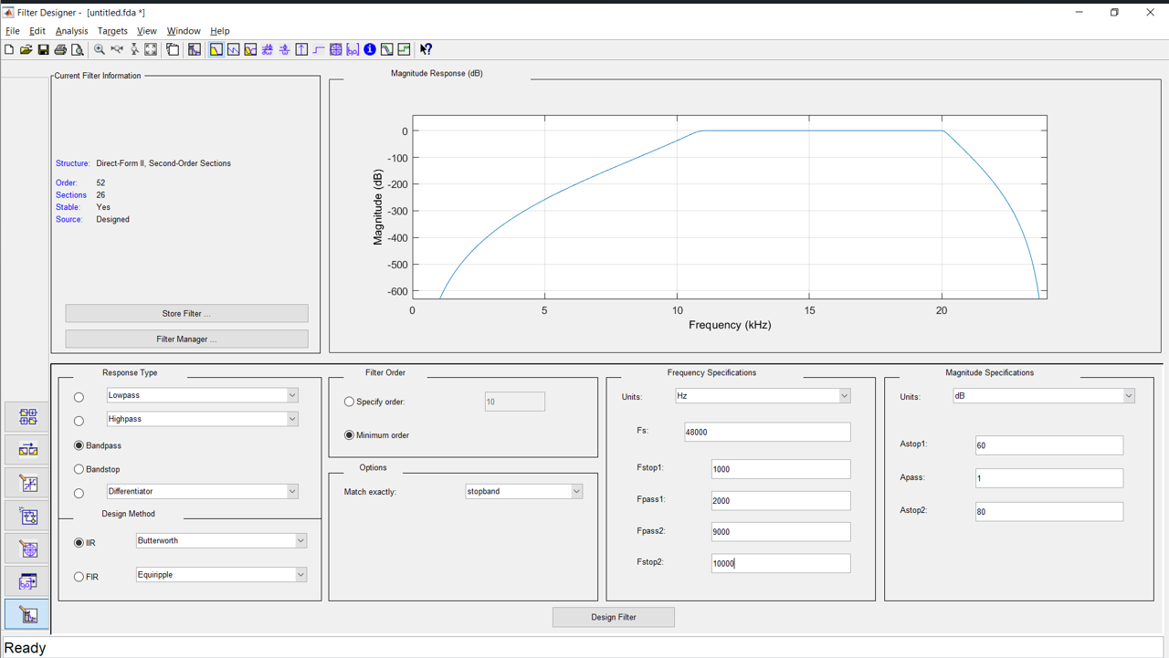

.the frequency response of the bandpass filter(14500 hz)

.

.the frequency response of the low pass filter(4000 hz)

This flow chart explain the steps of work :

The input signal

Get the carrier signal

Get the modulated signal to each signals and then adding the signal

Make a band bass filter to chose the signal we want to be modulated

Multiply the modulated signal with the carrier signal

Make a filter with gain (2)

Get the demodulated signal (output)

References:

- https://youtu.be/g3sfmjWkz5Q?si=Id_7uHqhuvtYGmvq
- https://youtube.com/shorts/9B8JbDSmFVE?si=eBBULLV_15JEGgXk
- https://youtu.be/d-QXxReQBxk?si=1WdIbrzOcztrbq37
- https://youtu.be/IJuLmLyV-Sk?si=pFqW_1s3zZKZPjp-
- https://youtu.be/1kCbeL8lE1c?si=SSc3LfyGdUMaYznU
- https://youtu.be/IJuLmLyV-Sk?si=mx7s4LvosOwxl6Y3

